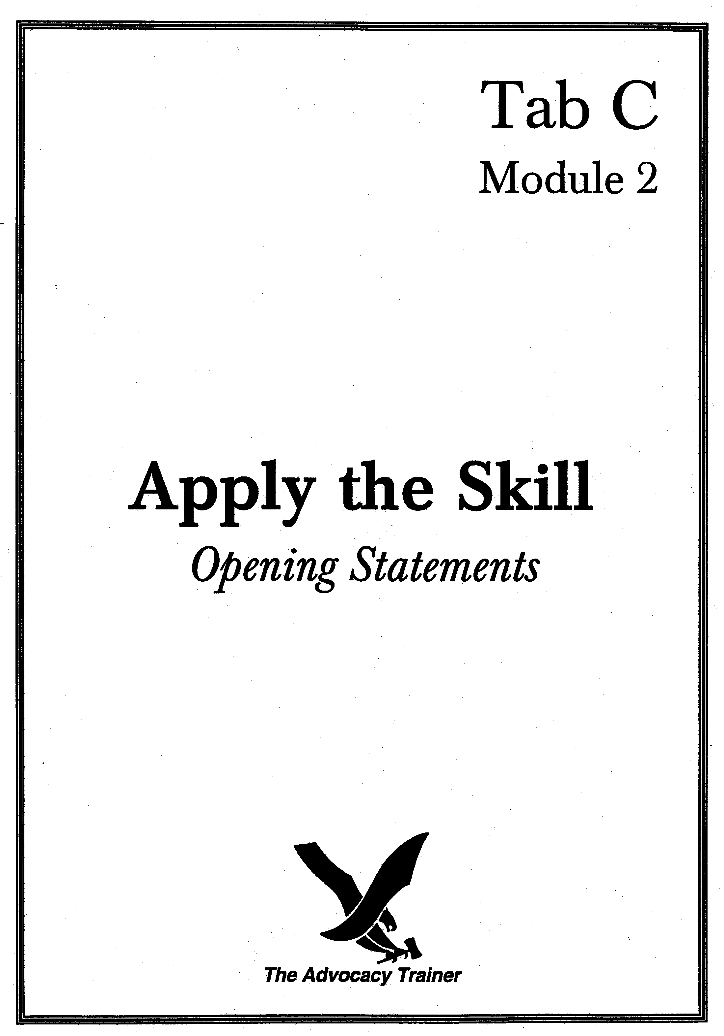

OPENING STATEMENTS
SUPERVISOR’S GUIDE

 SKILL OVERVIEW.

Goal. Develop counsel’s ability to prepare and deliver an opening statement.

Training Overview. This module requires two people: you and one of your counsel. When you have more than one counsel, have them sit in a panel area, so your counsel must address members while also in the presence of the military judge. Direct your counsel to prepare the statement ahead of time (when you give notice of the training), so that the training session consists solely of counsel’s statement, your critique and then, perhaps, redelivery of the statement or parts of the statement, incorporating your direction. It is an excellent exercise for videotape.

 THE LAW.

“Each party may make one opening statement to the court-martial before presentation of evidence has begun. The defense may elect to make its statement after the prosecution has rested, before the presentation of evidence for the defense. The military judge may, as a matter of discretion, permit the parties to address the court-martial at other times.” RCM 913(b).

This is an area in which there is little law and in which objections are rarely sustained unless they involve arguing, or mischaracterizing or overstating what the evidence will show.

 the art.

Theory, theme, themela. Help counsel understand these critical concepts, as they often find them dense.
- Theory is an adaptation of a set of facts to legal issues in the case, the meshing of facts with the law to prove guilt or acquit.
- Theme illustrates the most personal and specific aspects of the case (e.g., accused is a timebomb or a predator, accused is a victim of misidentification, vindictive charge of rape), the aspects that provide the moral force, the who and why that bring your case to life.
- Themela is the still more personalized application of a broad theme to this case (e.g., accused harbored a grudge that resulted in his exploding in this instance; accused is a misunderstood, sensitive soul whose actions reflect an unbalanced but good faith desire to right wrongs). Themela marries logic and the elements to emotion or human nature. Counsel should be able to express the theme in a sentence or so, and it should permeate the statement.

Remember housekeeping. If nothing else, an opening should be, in the tired analogy, a road map that tells panels (for whom briefing is a universal experience) what’s coming and who’s going to deliver. After trial counsel’s (TC) opening the members should not only be prepared to vote for you, but they should know who they’re going to see and roughly in what sequence. After the defense opening, the panel does not necessarily have to be ready to acquit, but it should be skeptical of aspects of the government case and have a sense of any major defense witnesses, if appropriate, or a fuller sense of the weaknesses of government evidence.

No arguing. Little is gained by appearing to “stretch the envelope” to the limits of argument, as a well-delivered opening is itself persuasive. Use the “witness test” to determine when an opening starts to morph into an argument. Counsel should consider whether they have a witness who will testify to the “facts” counsel present in the opening. If not, it is argument. Look for extended narratives about witnesses’s credibility; that is argument.

Start strong and end strong. This is classic “primacy and recency;” people remember best what they hear first and last. Opening statements are not spontaneous. Though they should not be read, they must be well planned and appear to be extemporaneous. You want to think hard about the first words out of your mouth; the same is true for your closing lines. As Churchill said, “the flowers of rhetoric are hothouse plants,” i.e., the best advocacy is well-planned but has the appearance and force of spontaneity.

Humanize the victim or accused. Part of this is terminology, but it should be more than calling the accused by name if defense counsel, or “the accused” if the government (in fact using full rank is sometimes effective for a TC when emphasizing forfeiture of respect). Counsel should paint pictures of victims or accused soldiers by placing them in scenarios or filling in human details that bring them to life; members will remember these facts and it will help counsel get past the temptation to look at the case as (merely) a contest between lawyers.

TC anticipate DC? Trial counsel may want to anticipate major points that they feel the defense is virtually certain to make in its opening or its case. Be careful here, however, as you cannot be certain the defense will say or do anything, you may open yourself to cheap objections and short speeches and corrective instructions (defense does not have to present anything, etc.), and you may say better what the defense would not have said as well. In addition, anticipation of such defense spin (other than through compensating for your weaknesses, addressed above) may appear weak, and may give the defense the chance to build on your perceived acknowledgment of the strength of its case.

Language. Panel members will summon mental images of people, places, facts, objects and locations from the words counsel use. Choose them advisedly, with precision and with understanding of their connotations. Consider the difference between “billiards parlor” and “pool hall.” Related: ensure counsel use military terminology correctly, not only official nomenclature, but “junior [not “lower”] enlisted” and “weapon,” not “gun.” Gripping language need not be flamboyant, so counsel should not strain to be poets. It is also important to avoid inside lingo, especially lawyer-speak or cop-speak (e.g., “exited the blue in color vehicle,” as opposed to “got out of the blue car”).

 PRACTICE POINTERS.
Discuss the following points with counsel.

- Get started. Avoid “this is a case about…” and other clichés, or use them with a novel twist. Sentence one of the opening statement should scream off the page and have something to do with this case, this crime, this accused or this victim. At some point you will want to introduce yourself and the major players, but not right away and not as the central component of the opening.

- Enthusiasm. Does not necessarily mean cheerleading or table pounding. It does mean caring – or seeming to care – strongly about the case and the position counsel are advocating. Enthusiasm is reflected in a number of ways, most obviously in inflection and word choice, but also a soldier’s command of the courtroom, a trial counsel’s organized presentation of a case, and a defense counsel’s unapologetic advocacy for a fellow soldier.

- Do not over-promise. Really only discuss what the evidence will show. There is no swifter way to lose credibility – and to play into the hands of an alert opponent – than to promise something in an opening and not deliver, inviting your opponent to flog you with it during his closing.

- Wield exhibits. If they’re worth showing to the panel, they’re worth showing as early and as often as possible; people learn best through multiple senses. Use exhibits in openings. If they are controversial or counsel are unsure of the judge, seek to either get them admitted in advance or to get permission to use them – but in the latter instance, be aware that counsel bear a substantial risk if they display evidence that they cannot later get admitted.

- No personal opinions. “I’m Kyle and I’ll be your waiter tonight, the special is…” Excise the word “I” from courtroom vocabulary. Sounds presumptuous, sanctimonious, too familiar, all things we do not want to be.

- No inside baseball. Don’t talk about the function of an opening statement, how it is not evidence, etc. It sounds defensive, panels don’t care, it invites them to ignore you, and the judge tells them anyway. This is not to say that you should not mention legal concepts to a panel. When a case turns on a significant legal point (e.g., knowing use of marijuana, consent in a rape case, divestiture in a disrespect case), expect a panel to understand your well-planned, lucid explanation of the law.

- Highlight your strengths. The other side will hammer at your weaknesses; when you have a particularly strong part to your case (e.g., extremely sympathetic victim, registered source with checkered past), you can hardly over-sell it. But…

- Compensate for your weaknesses. You should volunteer and account for significant weaknesses. Not every weakness. Some appear to be more important to you, and some will slip past your opponent. Counsel need to address the obvious weaknesses in the case – perhaps compromises made by your victim, lab errors, admissions by your client or “bad witnesses” impeachable under MREs 609, 404(b), 405(a), 608, 613 or 801(b) –but should do so with a plan. It does show your candor and suggests a sense of balance, but you should couple the admission with a compensating fact that diminishes the damage and gives the panel an “out” or better context in which to place the weakness.

- When to wait. Generally, the defense will want to present its statement right away, on the theory that minds are made up early. The defense may want to consider postponing its statement until the beginning of its case when it is not going to contest the facts but present an affirmative defense; in such a circumstance it would have raised the defense in cross of government witnesses, and can use the opening statement as an early window into the closing argument.

- Delivery and Technique. Again, counsel should not read, though opening statements should be prepared and rehearsed. Eye contact with the panel and the appearance that counsel is talking to them is paramount. Counsel normally should deliver the statement from a lectern or podium, but should move enough to emphasize certain points and engage the panel. Trial counsel can point to the accused at this stage, making it clear that there is an adversarial relationship in the courtroom and that the government aims to convict; the defense can begin the humanizing of the accused by physically referring to the accused, preparing for the panel’s scrutiny of him.



 SKILL DRILLS

Goal. Train counsel to deliver a powerful opening statement.

Conduct the drills.

Preparation. Give notice of time and date of training with guidance to prepare an opening statement from an upcoming or previous case. Or provide them some facts or a short case file and direct them to prepare an opening statement.

Execution.

Choose an aspect, or several aspects, of an opening statement and tell counsel to prepare their opening, or segment of opening statement, with special emphasis on the skills required. You can still have them deliver an entire opening, but narrow your critique to an aspect below, advising counsel that you simply are not evaluating for other aspects at this time. Have them prepare an opening for a future case, but you can also have them give an opening for a case already tried or for simple facts you create. For example, deliver an opening (or segment) that focuses on:
- Theme: all parts of the statement relate to a central theme.
- Organization: why certain parts of the statement appear in the sequences they do; transitions.
- Primacy and recency (start and end strong).
- Humanizing the accused or victims.
- Language: precise and appropriate language (avoid jargon, use military and technical terms correctly), use strong impact words, avoid verbosity and legalese.
- Foregoing expression of opinion, while presenting a compelling view of the case.
- Use of exhibits.
- Defuse weaknesses.
- Incorporating anticipated instructions.
- Delivery mechanics (use videotape).

Set a time limit, perhaps 8-10 minutes for a full opening, less if you are only evaluating a portion of the statement.

There is no “school solution” to this exercise, because counsel should give opening statements on concluded or upcoming cases. Stop them during their statements as they deliver information that is objectionable, unclear, or misleading. Concentrate on the aspect of opening statements that is the focus of this drill and on which you gave counsel notice to prepare. This also enables you to conduct many opening statement drills, because aspects of the same statement can be given more than one time, until the teaching value is exhausted. You may, for example, want to concentrate on arguing. Some counsel think it clever or helpful to walk right up to the line separating statement from argument, and even to tiptoe (if not leap) over it, daring the opponent to object or the judge to interject. Arguing in an opening, besides being a violation of the rules, rarely does much to advance your cause. A statement can still be (should be) gripping; it cannot, however, overtly ask the panel to make judgments by arguing the links between the evidence, witness motives and the like, to the party’s theory of the case. Force counsel to drop argumentative phrases and statements and to focus on presenting facts in a way that advances a theme.

“Skull Session”: Starting and stopping. Pull an opening from a record of trial. Photocopy it and have counsel draw a line at the point at which the statement starts to have anything to do with the case at hand. Frequently counsel “wheel spin” through a paragraph or two or three in which they issue generalities about what an opening statement is, who has what burden, who they are, etc. Now look at the first sentence that relates to this case or client. Start with that and make it as punchy and engaging as possible. Discourage them from generic opening lines; such blandishments quickly bore a panel that often then misses the real start to the statement when you start to state your case.

End strong, too. Draw a line at the end of opening statements when counsel diverge from the case at hand and go into closing generalities about the burden, keeping an open mind, paying attention to all of the evidence, listening to the judge, paying attention to cross, etc. Look at the last line during which counsel actually talked about the case. Now make that punchier and more dramatic. Then stop.

 Summarize the Main Teaching Points.
- Tie all statements to a central theme.
- Avoid too much time on preliminary matters.
- Present facts in an active, assertive manner.
- Pay particular attention to opening and closing lines.
- Don’t argue.
- Avoid excess reliance on notes.
- Avoid distracting mannerisms.

 REFERENCES.

Thomas A. Mauet, Trial Techniques chapt. 3 (4th ed. 1996).

Trial Counsel Assistance Program Memo #54 (Advocacy Supplement) (June 1990).

Michael Marcus, Trial Preparation for Prosecutors chapt. 19 (1989).

Steven Lubet, Modern Trial Advocacy (1993).

opening statements
counsel handout

 training overview.

Introduction. The next trial advocacy training session, scheduled on _______________, from ______ to ______ hours, will focus on opening statements. The training will be conducted in two parts. First, I will lead a discussion about the various techniques necessary for an effective opening statement. After a short break, we will reconvene for the second part of the training, during which counsel will deliver an opening statement, or part of an opening statement.

Preparation. Counsel must bring their Manual for Courts-Martial to this trial advocacy training session. Counsel must also be prepared to deliver an opening statement from an upcoming case, a prior case, or from a fictitious scenario I provide. Finally, counsel will review, and be prepared to discuss, the opening statement skills listed in part II.

 keys to success.

Theory and theme.

Remember - an opening statement is a roadmap.

No arguing. 

Start strong and end strong. 

Start with a punch - no generic opening lines.

End forcefully - no closing generalities.

Humanize the victim or accused.

Highlight your strengths - compensate for your weaknesses with a plan.

Language.

Use strong impact words.

Avoid verbosity and legalese.

Use precise language.

 references for further study.

Thomas A. Mauet, Trial Techniques chapt. 3 (4th ed. 1996).

Trial Counsel Assistance Program Memo #54 (Advocacy Supplement) (June 1990).

Michael Marcus, Trial Preparation for Prosecutors chapt. 19 (1989).

Steven Lubet, Modern Trial Advocacy (1993).

